CSC494 Report

Fengjia Zhang

Yuhan Shao

1. DISK_ONLY and MEMORY_AND_DISK comparison in spark command
   1. In ext4

|  |  |  |
| --- | --- | --- |
|  | MEMORY_AND_DISK | DISK_ONLY |
| Performance drop  (the amount of time) | Without blktrace  real 2m18.379s  user 45m4.699s  sys 1m7.734s  With blktrace  real 2m13.066s  user 44m53.089s  sys 1m8.120s | Without blktrace  real 4m16.086s  user 80m29.434s  sys 5m0.749s  With blktrace  real 4m12.011s  user 80m57.390s  sys 5m1.255s |
| Blktrace file size | 1634736 | 2811764 |
| blocks written | 10,761, 9,112MiB | 18,599, 14,663MiB |
| blocks read | 0, 0KiB | 1, 4KiB |

Frequency distribution for MEMORY_AND_DISK:

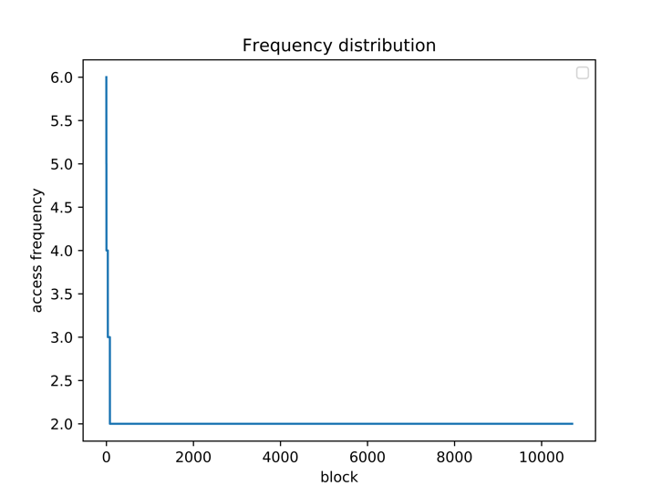

Focusing on the most frequent 250 blocks:

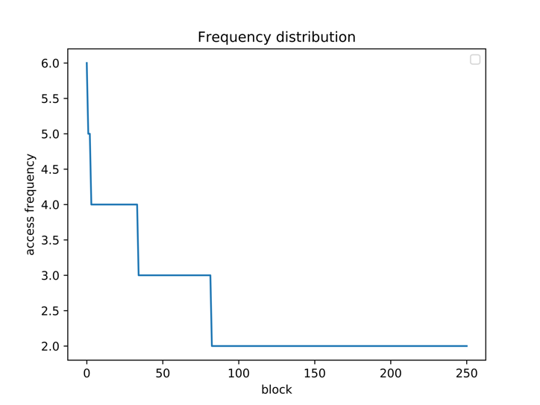

Frequency distribution for DISK_ONLY:

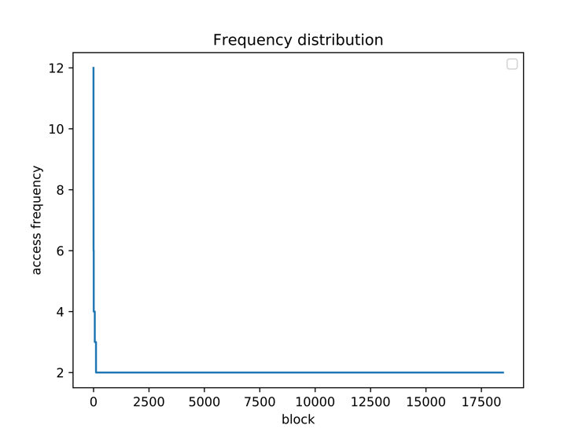

Focusing on the most frequent 250 blocks:

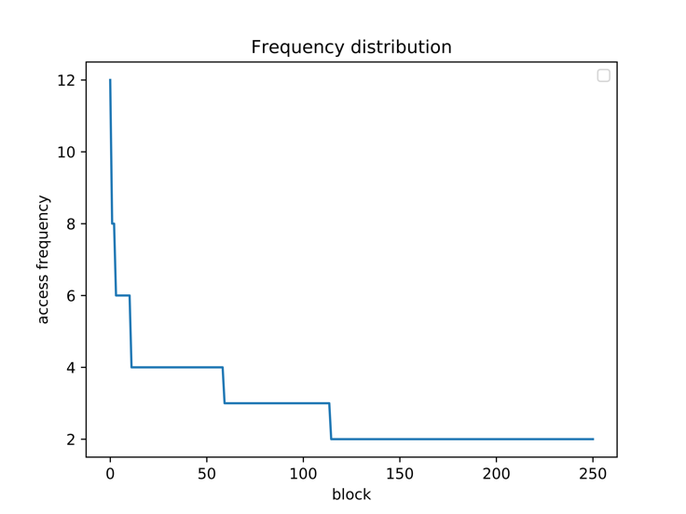

Overall Comparison:

Graph

Analysis:

Text

Read and write ratio for MEMORY_AND_DISK:

Graph

Read and write ratio for DISK_ONLY:

Graph

Overall Comparison:

Graph

Analysis:

Text

* 1. In btrfs

|  |  |  |
| --- | --- | --- |
|  | MEMORY_AND_DISK | DISK_ONLY |
| Performance drop  (the amount of time) | Without blktrace  real 3m7.707s  user 44m4.280s  sys 13m56.787s  With blktrace  real 3m10.161s  user 44m40.151s  sys 13m50.994s | Without blktrace  real 4m48.651s  user 80m34.261s  sys 16m9.468s  With blktrace  real 5m2.474s  user 83m55.573s  sys 15m57.412s |
| Blktrace file size | 1919724 | 2519014 |
| blocks written | 12,743, 14,419MiB | 16,736, 14,772MiB |
| blocks read | 0, 0KiB | 0, 0KiB |

Frequency distribution for MEMORY_AND_DISK:

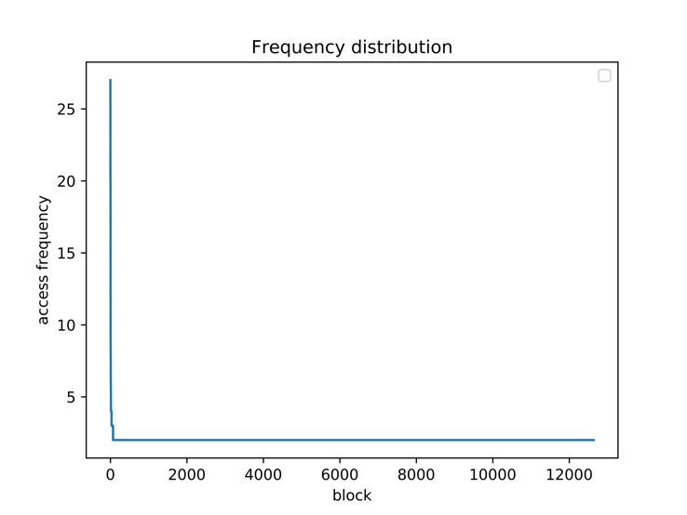

Focusing on the most frequent 250 blocks:

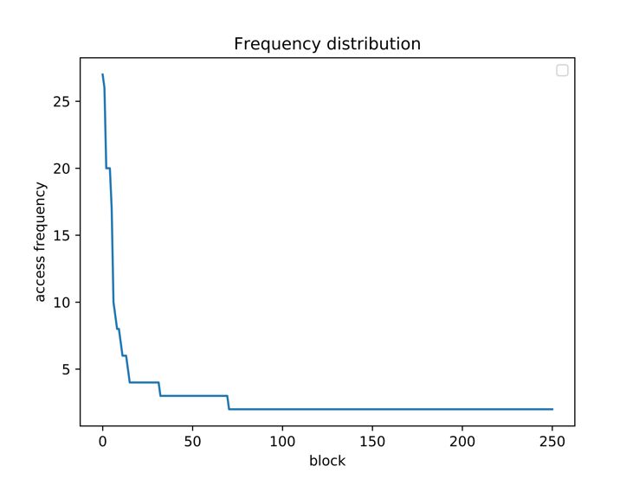

Frequency distribution for DISK_ONLY:

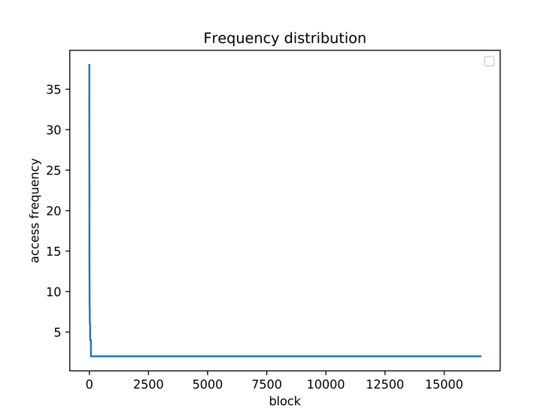

Focusing on the most frequent 250 blocks:

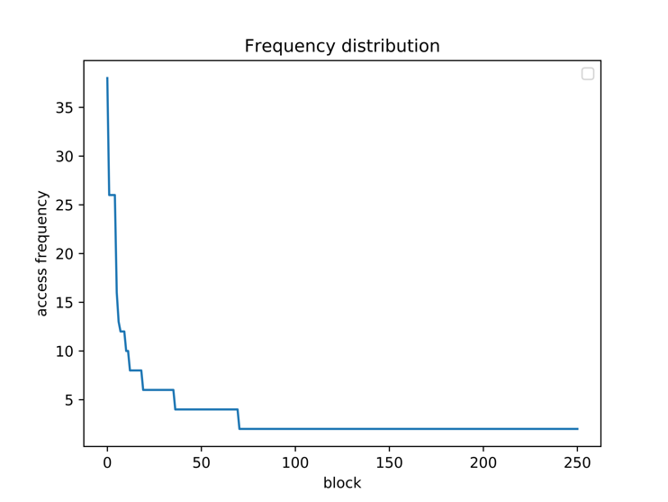

Overall Comparison:

Graph

Analysis:

Text

Read and write ratio for MEMORY_AND_DISK:

Graph

Read and write ratio for DISK_ONLY:

Graph

Overall Comparison:

Graph

Analysis:

Text

* 1. In f2fs

|  |  |  |
| --- | --- | --- |
|  | MEMORY_AND_DISK | DISK_ONLY |
| Performance drop  (the amount of time) | Without blktrace  real 4m36.656s  user 44m14.205s  sys 1m6.152s  With blktrace  real 5m39.593s  user 44m38.928s  sys 1m6.234s | Without blktrace  real 5m14.525s  user 82m4.652s  sys 4m46.754s  With blktrace  real 4m58.157s  user 82m25.109s  sys 4m43.383s |
| Blktrace file size | 10028000 | 11107003 |
| blocks written | 73,079, 10,945MiB | 80,354, 19,365MiB |
| blocks read | 0, 0KiB | 0, 0KiB |

Frequency distribution for MEMORY_AND_DISK:

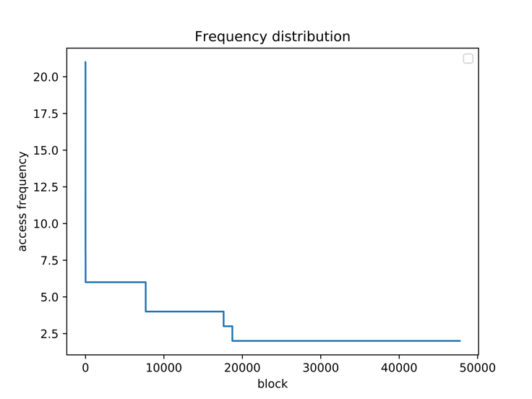

Focusing on the most frequent 250 blocks:

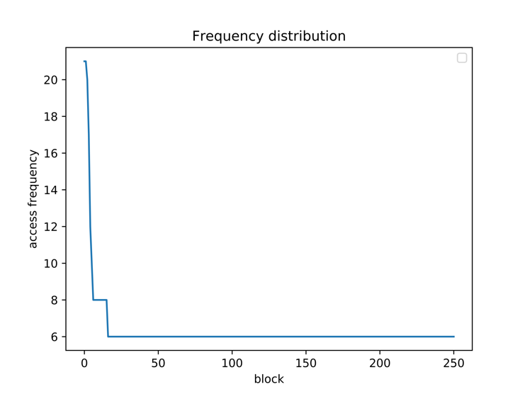

Frequency distribution for DISK_ONLY:

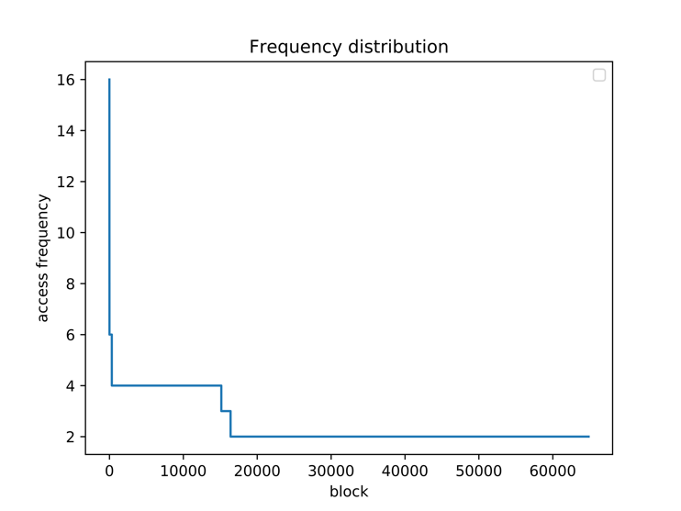

Focusing on the most frequent 250 blocks:

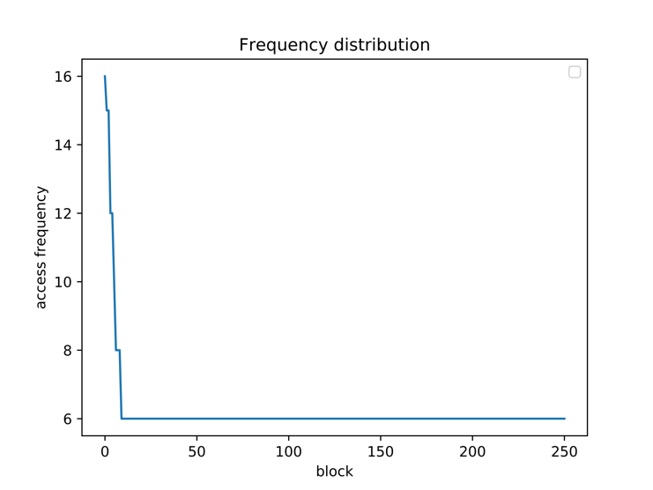

Overall Comparison:

Graph

Analysis:

Text

Read and write ratio for MEMORY_AND_DISK:

Graph

Read and write ratio for DISK_ONLY:

Graph

Overall Comparison:

Graph

Analysis:

Text

1. File System Comparison
   1. Command:
      1. Blocktrace

mkdir blocktrace

sudo mkfs.ext4 /dev/nvme2n1

sudo mount /dev/nvme2n1 blocktrace

sudo blktrace -d /dev/nvme1n1 -w 3600 -o - | blkparse -a fs -i - > blocktrace/filename

* + 1. Spark on different file system

mkdir spark

sudo mkfs.ext4 /dev/nvme1n1 //ext4

sudo mkfs.btrfs -f /dev/nvme1n1 // Btrfs

sudo mkfs.f2fs /dev/nvme1n1 // F2FS

sudo mount /dev/nvme1n1 spark

sudo mount // to check whether the file system is formatted correctly

// sudo umount spark

// copy the spark to the folder spark

scp -r shaoyuha@swift-014.syslab.sandbox:/home/shaoyuha/spark-2.4.0-bin-hadoop2.7 ./spark

time ./bin/run-example graphx.Analytics pagerank ../twitter_rv.net --numEPart=-1 --vertexStorageLevel=MEMORY_AND_DISK --edgeStorageLevel=MEMORY_AND_DISK

* 1. Output:

|  |  |  |  |
| --- | --- | --- | --- |
|  | ext4 | Btrfs | F2FS |
| Performance drop  (the amount of time) | Without blktrace  real 2m18.379s  user 45m4.699s  sys 1m7.734s  With blktrace  real 2m13.066s  user 44m53.089s  sys 1m8.120s | Without blktrace  real 3m7.707s  user 44m4.280s  sys 13m56.787s  With blktrace  real 3m10.161s  user 44m40.151s  sys 13m50.994s | Without blktrace  real 4m36.656s  user 44m14.205s  sys 1m6.152s  With blktrace  real 5m39.593s  user 44m38.928s  sys 1m6.234s |
| Blktrace file size | 1634736 | 1919724 | 10028000 |
| blocks written | 10,761, 9,112MiB | 12,743, 14,419MiB | 73,079, 10,945MiB |
| blocks read | 0, 0KiB | 0, 0KiB | 0, 0KiB |

Frequency distribution for ext4:



Focusing on the most frequent 250 blocks:



Frequency distribution for Btrfs:



Focusing on the most frequent 250 blocks:



Frequency distribution for F2FS:



Focusing on the most frequent 250 blocks:



Overall Comparison:

Graph

Analysis:

Text

Read and write ratio for ext4:

Graph

Read and write ratio for Btrfs:

Graph

Read and write ratio for F2FS:

Graph

Overall Comparison:

Graph

Analysis:

Text

1. Related Files
   1. Workload

spark-2.4.0-bin-hadoop2.7 sx-stackoverflow.edges

Stored under zhangf68@swift-014:~/spark$

* 1. Blktrace’s, Png’s, Csv’s

Stored under zhangf68@swift-014:~$